SIMATS ENGINEERING (SAVEETHA SCHOOL OF ENGINEERING)
Department of Computer Science and Engineering
CO2 ASSESSMENT TOOL 2 – Architecture Design Assignment

Course Code: | CSA10 | Course Title: | Software Engineering
CO Assessed: | CO2 | Assessment: | Assessment Tool 2 – Architecture Design Assignment
Weightage: | 20% | Total Marks: | 25
CO2 Statement: | Perform detailed requirements analysis, design scalable architectures, and prioritize features with a focus on cross-disciplinary skills
Student Name: | K Sujith Sai Vighnesh | Reg. No.: | 192311199
Date: | 04-08-2026 | Duration: | 60 minutes

Code of Conduct
I K.Sujith Sai Vighnesh—192311199 certify that this submission is my original work and that I have adhered to the guidelines specified for this assessment. I understand that any violation of academic integrity rules will result in disciplinary action.
Signature of the Student: K Sujith Sai Vighnesh
Annexure A – Architecture Design Assignment
Instructions to Students:
Each student will be assigned an individual software project problem statement. Based on the assigned problem, analyze the system requirements and design an appropriate software architecture by applying software engineering principles. Your submission should demonstrate your ability to select, justify, and evaluate a suitable architectural style.

Question
Based on your assigned problem statement, perform an Architecture Design Analysis and prepare an architecture design report by answering the following questions:
1. Analyze System Requirements
- Study the given problem statement and identify the system objectives.
- Analyze the functional and non-functional requirements that influence the software architecture.
- Identify key quality attributes such as scalability, maintainability, reliability, availability, performance, and security.

2. Select a Suitable Software Architecture
- Select an appropriate architectural style for the proposed system (e.g., Layered Architecture, Client-Server, MVC, Microservices, Event-Driven, Service-Oriented Architecture, Serverless, or Hybrid Architecture).
- Justify why the selected architecture is the most suitable for the given problem.

3. Draw the Software Architecture Diagram
- Design a clear architecture diagram illustrating the overall structure of the proposed system.
- Include all major layers/components, databases, external systems, APIs, and communication mechanisms.
- Use appropriate software architecture notations and labels.

4. Explain Components and Their Interactions
- Describe the purpose and responsibilities of each architectural component.
- Explain how the components communicate and exchange data.
- Illustrate the overall workflow of the system.

5. Discuss Quality Attributes
Evaluate how the proposed architecture addresses the following aspects:
- Scalability
- Security
- Performance
- Reliability
- Maintainability
- Availability

6. Justify Architectural Decisions
- Explain the rationale behind your architectural choices.
- Discuss the trade-offs considered while selecting the architecture.
- Explain how the chosen architecture supports future enhancements, system integration, and long-term maintainability.
Rubrics for Calculation
Evaluation Criteria | Excellent (4 Marks) | Good (3 Marks) | Satisfactory (2 Marks) | Needs Improvement (1 Mark)
System Requirement Analysis | Thoroughly analyzes the problem statement, accurately identifies functional and non-functional influencing the architecture. | Analyzes most requirements with minor omissions or limited explanation. | Identifies only basic requirements with partial analysis. | Requirement analysis is incomplete, inaccurate, or lacks clarity.
Selection of Software Architecture | Selects the most appropriate architectural style with strong technical justification aligned to system requirements. | Selects a suitable architecture with reasonable justification. | Architecture is partially suitable with limited justification. | Inappropriate architecture selected or justification is missing.
Architecture Diagram and Component Design | Produces a clear, complete, and well-structured architecture diagram with all major components, interfaces, and interactions accurately represented. | Diagram is mostly complete with minor omissions or notation issues. | Diagram includes only essential components and lacks sufficient detail. | Diagram is incomplete, unclear, or technically incorrect.
Component Interaction and Quality Attribute Analysis | Clearly explains component responsibilities, interactions, and thoroughly functional requirements. | Explains most components and quality attributes with minor gaps. | Provides limited explanation of interactions and addresses only some quality attributes. | Component interactions and quality attributes are poorly explained or missing.
Architectural Justification and Technical Presentation | Provides strong justification for architectural decisions, discusses trade-offs and future enhancements, and presents a well-organized, professional report. | Provides adequate justification with minor gaps; report is well organized. | Limited justification with minimal discussion of trade-offs or future scope. | Justification is weak or absent; report lacks organization and technical clarity.

ARCHITECTURE DESIGN ANALYSIS REPORT
AI-Powered Smart Disaster Relief Resource Allocation and Coordination Platform
Annexure A — Architecture Design Assignment

1. System Requirement Analysis

1.1 System Objectives
- Monitor disaster relief resources in real time.
- Predict resource demand using AI.
- Optimize relief distribution routes.
- Coordinate multiple relief agencies.
- Monitor shelter occupancy.
- Improve disaster response efficiency and reduce distribution delays.

1.2 Functional Requirements Influencing the Architecture
- Real-time ingestion and processing of IoT/GIS sensor data for severity assessment.
- AI/ML-based demand forecasting that must be trained, versioned, and served independently of other modules.
- Route optimization requiring integration with external mapping/traffic APIs.
- Simultaneous, role-based access for multiple independent organizations (government, NGOs, citizens).

1.3 Non-Functional Requirements Influencing the Architecture
Quality Attribute | Why It Matters for This System
Scalability | User load and data volume can spike 10x within hours as a disaster unfolds, requiring components to scale independently (e.g., alerting vs. reporting).
Reliability | Coordination and inventory services must keep functioning even if a single module (e.g., analytics) fails, since lives depend on relief delivery.
Availability | The platform must remain reachable from disaster zones with degraded connectivity, and tolerate partial infrastructure outages.
Performance | Severity scoring, demand forecasts, and route recalculation must return results in seconds to stay useful during active response.
Security | Sensitive citizen, location, and inter-agency data require strict authentication, authorization, and encryption.
Maintainability | Independent teams (AI, GIS, logistics, coordination) must be able to update their module without redeploying the entire platform.
Interoperability | The system must integrate with heterogeneous external systems — government databases, GIS providers, weather APIs, SMS gateways.

2. Selection of Suitable Software Architecture

2.1 Selected Architectural Style
A Hybrid Microservices + Event-Driven Architecture, fronted by an API Gateway, is selected for this platform. Each major capability (inventory, severity assessment, AI prediction, logistics/routing, coordination, shelter management, reporting, user management) is implemented as an independently deployable microservice. Services communicate synchronously via REST/HTTPS through the API Gateway for client-facing requests, and asynchronously via an event bus (Kafka/MQTT) for real-time data streams such as IoT sensor feeds, inventory changes, and cross-agency alerts.

2.2 Justification
- Independent scalability: during a disaster, alerting and severity-assessment traffic can spike independently of reporting traffic — microservices allow each to scale on its own.
- Fault isolation: if the AI prediction service or an external GIS API is degraded, core operations such as inventory tracking and coordination continue functioning.
- Real-time data needs: an event-driven backbone naturally fits continuous IoT/GIS sensor streams and cross-agency notifications, which are poorly suited to a purely synchronous, monolithic request/response model.
- Independent development and deployment: separate teams (AI/ML, GIS, logistics, coordination) can build, test, and release their services independently, matching the multi-stakeholder nature of the project.
- Polyglot persistence: different services have very different data needs (geospatial/time-series data for severity, relational data for inventory, model artifacts for AI) — microservices allow each to use the most appropriate datastore.
- A pure monolith would not isolate failures or scale unevenly-loaded features; a pure event-driven (no services) design would lack clear synchronous request/response boundaries needed for client dashboards; a hybrid combines the strengths of both.

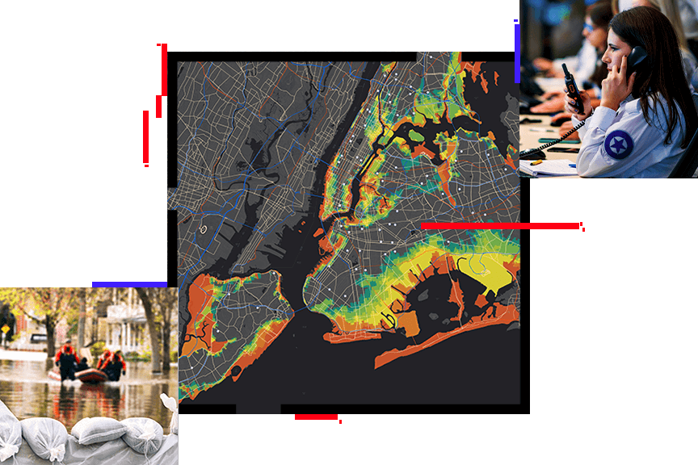

3. Software Architecture Diagram
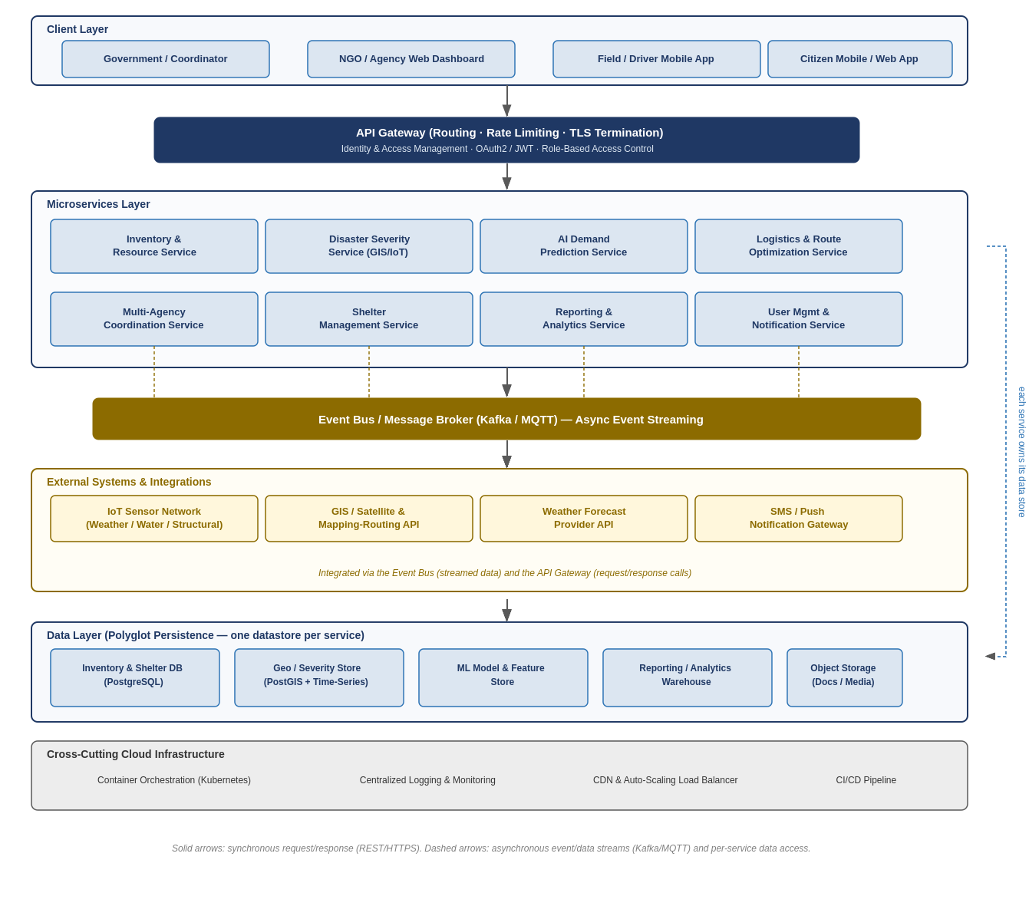
Figure 1: Hybrid Microservices + Event-Driven Architecture — AI-Powered Disaster Relief Coordination Platform.
4. Components and Their Interactions

4.1 Component Responsibilities
Component | Responsibility
Client Layer | Web dashboards (government/NGO) and mobile apps (field staff, drivers, citizens) that present data and capture user input.
API Gateway | Single entry point for all client requests; handles routing, TLS termination, rate limiting, and delegates authentication/authorization.
Identity & Access Management | Issues and validates OAuth2/JWT tokens; enforces role-based access control across all services.
Inventory & Resource Service | Tracks stock levels, thresholds, and low-stock alerts for relief supplies.
Disaster Severity Service | Ingests GIS/IoT data and computes per-zone severity scores and classifications.
AI Demand Prediction Service | Runs ML models to forecast resource needs from severity, population, and historical data.
Logistics & Route Optimization Service | Computes optimal delivery routes and tracks vehicles, using external mapping/traffic data.
Multi-Agency Coordination Service | Maintains the shared operational view, zone/task assignment, and cross-agency alerting.
Shelter Management Service | Tracks shelter capacity/occupancy and serves citizen shelter-search queries.
Reporting & Analytics Service | Aggregates data into logistics reports and coverage-gap dashboards.
User Management & Notification Service | Manages accounts/roles and dispatches SMS/push notifications.
Event Bus (Kafka/MQTT) | Decouples services via publish/subscribe; carries IoT sensor events, inventory changes, and alerts in real time.
Data Layer | Polyglot persistence — each service owns a datastore suited to its data shape (relational, geospatial/time-series, model store, warehouse, object storage).
External Systems | IoT sensor network, GIS/mapping-routing API, weather provider, and SMS/push gateway integrated via the event bus and API Gateway.
Cloud Infrastructure | Kubernetes orchestration, centralized logging/monitoring, CDN/load balancing, and CI/CD for deployment automation.

4.2 Communication Mechanisms
- Synchronous (REST/HTTPS): client-to-gateway and gateway-to-service calls for on-demand actions — e.g., a coordinator requesting a demand forecast, a citizen searching shelters.
- Asynchronous (Kafka/MQTT events): IoT sensor readings, inventory changes, and cross-agency alerts are published as events and consumed by any interested service without tight coupling.
- Each microservice exposes a versioned API and owns its own datastore; other services never access another service's database directly, only through its API or published events.

4.3 Overall System Workflow
- 1. IoT sensors and GIS feeds continuously publish readings to the Event Bus.
- 2. The Disaster Severity Service consumes these events and computes an updated severity score per zone.
- 3. The AI Demand Prediction Service consumes severity updates (plus population data) to refresh resource forecasts.
- 4. Relief Coordinators view forecasts and current inventory through the Web Dashboard, routed via the API Gateway to the relevant services.
- 5. The Logistics Service plans optimized delivery routes, publishing vehicle-tracking events consumed by the Coordination Service dashboard.
- 6. As shipments are delivered, the Inventory Service updates stock levels and publishes low-stock alerts through the Event Bus, triggering notifications via the Notification Service.
- 7. The Reporting Service subscribes to relevant events across services to build logistics reports and analytics dashboards without impacting operational service performance.

5. Quality Attribute Discussion
Attribute | How the Architecture Addresses It
Scalability | Each microservice can be scaled horizontally and independently (e.g., auto-scaling the Severity and Notification services during peak disaster load) without over-provisioning less-loaded services like Reporting.
Security | The API Gateway centralizes authentication/authorization (OAuth2/JWT, RBAC); TLS is enforced end-to-end; each service's datastore is isolated, limiting blast radius of a breach.
Performance | Read-heavy dashboards can use caching at the gateway/service level; the event-driven backbone avoids blocking calls for high-frequency IoT data, keeping severity and alerting responsive.
Reliability | Failure of a non-critical service (e.g., Reporting) does not cascade to critical services (Inventory, Coordination) because they are decoupled through the event bus and independent deployments.
Maintainability | Teams can update, test, and redeploy a single service (e.g., improving the AI model) without touching or redeploying unrelated services, reducing regression risk.
Availability | Container orchestration (Kubernetes) enables automatic restarts and multi-instance redundancy; the event bus buffers messages so temporary service outages do not lose data.

6. Justification of Architectural Decisions

6.1 Rationale
The hybrid microservices + event-driven approach was chosen over a monolithic or purely layered architecture because the problem domain has clearly separable capabilities (inventory, severity, prediction, logistics, coordination, shelters, reporting) with different scaling, reliability, and data needs, and because real-time IoT/GIS data streams are a first-class requirement rather than an afterthought.

6.2 Trade-offs Considered
- Operational complexity: running many services and an event bus requires stronger DevOps practices (container orchestration, monitoring, CI/CD) than a monolith — accepted because it is offset by independent scalability and fault isolation, which matter more in a life-critical system.
- Data consistency: polyglot, per-service persistence means the system is eventually consistent across services rather than strongly consistent — acceptable for this domain, since slightly delayed propagation of a report is far less costly than a single point of failure taking down the whole platform.
- Latency overhead: inter-service calls and event processing add some latency compared to in-process monolith calls — mitigated by keeping latency-critical paths (severity, alerts) on the fast event-bus path and asynchronous, non-urgent work (reporting) fully decoupled.
- A simpler layered/client-server architecture was considered but rejected: it would couple all features to a single deployable unit, making it harder to scale IoT-heavy severity processing independently of low-traffic reporting, and a single bug could take down the entire relief coordination platform during an active disaster.

6.3 Support for Future Enhancements, Integration, and Long-Term Maintainability
- New capabilities (e.g., drone-based delivery, donation payment processing) can be added as new microservices that subscribe to existing events without modifying current services.
- Additional external integrations (new government systems, new GIS/weather providers) plug in at the API Gateway or Event Bus boundary, minimizing impact on internal services.
- The AI Demand Prediction model can be retrained, A/B tested, or replaced independently, since it is isolated behind its own service API.
- Because each service owns its data and API contract, the platform can evolve technology choices per service over time (e.g., migrating one service's datastore) without a full-system rewrite.
- Kubernetes-based deployment and CI/CD support incremental rollout of new features with minimal downtime, which is critical for a platform that must remain operational during active disasters.



